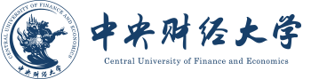

CERTIFICATE OF BACHELOR’S DEGREE

This is to certify that Zhang Sun, female/male, born on August 25, 1999, has successfully completed an undergraduate program at the Central University of Finance and Economics, majoring in Translation (Finance and Economics) and minoring in Finance. In accordance with the Regulations of the People’s Republic of China on Academic Degrees, and approved by the university’s Degree Appraisal Committee, the aforesaid student is hereby awarded the degree of Bachelor of Arts (major) and Economics (minor).

Wang Yaoqi
President, and Chair of Degree Appraisal Committee
Central University of Finance and Economics
Issued on June 7, 2022
Certificate No. 1003442022101666

