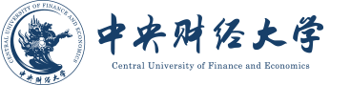

CERTIFICATE OF GRADUATION

This is to certify that Wang Shu, female/male, born on August 22, 1999, has successfully completed a four-year undergraduate program from September 2018 to June 2022 in the School of Finance, Central University of Finance and Economics, majoring in Finance. Having completed all the required courses of study and having complied with all other requirements, the aforesaid student is hereby granted graduation.

Wang Yaoqi
President, Central University of Finance and Economics
Issued on June 7, 2022
Certificate No. 100341202205001888

