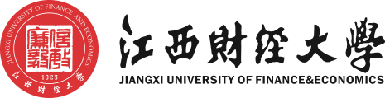
毕业证书

邓XX，男/女，一九九〇年三月二十九日生。于二〇〇七年九月至二〇一一年七月在江西财经大学会计学（ACCA方向）专业四年制本科学习，修完教学计划规定的全部课程，成绩合格，准予毕业。

校名：江西财经大学 校（院）长：王乔
证书编号：104211201105002xxx 二〇一一年七月十日

Certificate of Graduation

This is to certify that Deng XX, male/female, born on March 29th, 1990, has studied from September 2007 to July 2011 majoring in Accounting (ACCA Orientation). He/She has completed all the courses prescribed in the 4-year undergraduate teaching program, passed all the exams necessary for graduation from Jiangxi University of Finance & Economics. At the end of the education period with satisfactory performance, he/she is approved graduation.

President: WANG Qiao
Jiangxi University of Finance & Economics
Certificate No.: 104211201105002xxx July 10th, 2011

学士学位证书

邓XX，男/女，一九九〇年三月二十九日生。在江西财经大学会计学（ACCA方向）专业完成了本科学习计划，业已毕业，经审核符合《中华人民共和国学位条例》的规定，授予管理学学士学位。

江西财经大学 学位评定委员会主席：王乔
证书编号：1042142011103xxx 二〇一一年七月十日

Certificate of Bachelor’s Degree

This is to certify that Deng XX, male/female, born on March 29th,1990, has completed undergraduate curriculum in the major of Accounting (ACCA Orientation)，Jiangxi University of Finance & Economics. In accordance with “The Regulations Concerning Academic Degrees in the People’s Republic of China”, he/she is awarded the Bachelor’s Degree of Management.

WANG Qiao
Chairman of Degree Awarding Committee,
Jiangxi University of Finance & Economics
Certificate No.: 1042142011103xxx July 10th, 2011

